Introduction

Corporate world has evolved from being economic capitalist to the economic environmentalist. Organisations are adapting more sustainable solutions that can generate social, economic and environmental benefits. 'Corporate Social Responsibility (CSR)' has become a regular policy in most organisations where they have integrated it in its operational practices. The paper discusses literature sources between 2008 and 2016 to understand strengths and weaknesses of CSR application in an organisation. The study focuses on three-fold approach Strategy, System and People to explore different perspective for CSR implementation.
For many researchers and observers alike, it remains difficult to understand fully how organizations design their CS R policies and communicate them to different stakeholders. They also have trouble determining different stakeholders' complex perceptions of and attitudes toward the organization, which means managerial guidelines are virtually non-existent in this important area.
3.1 Introduction to IKEA
IKEA is a global company which is present in 37 countries and has approximately 127 800 employees Ingvar Kamprad founded IKEA in 1943. In 1947, he started to sell furniture and in 1955 IKEA started to design its own furniture. IKEA started as a mail order company, but this soon changed and the first store was opened in Älmhult - later it became the model for all IKEA establishments. IKEA is regarded as one of the most respected and reliable companies in Sweden and has become one of the most popular companies to work for. order to understand and analyse current CSR activities in IKEA, it I by looking into the foundation on which IKEA was built and the values and vision, which the founder Ingvar Kamprad instilled into the company culture from the beginning.

IKEA is a "living brand" that cultivates 'living' aspect that generates how its stores operates innovates store operation by prioritizing consumer need as driving force. IKEA emphasize heavily on its people, planet and profit perspective. The sustainable key indicators and embedded in its operational policy and values. The sustainable policies help in branding the image of corporations as 'green brands' that not only wants to optimize its profit but also have social consciousness. Its business model has evolved over time and has become more sustainable. The social approach of IKEA operations is highly motivated to empower its stakeholders. From recruitment to operation, all employs at IKEA are committed to work for their customers. This attitude has developed a close connection with the consumer market.

BODY
- What are the issues that company faces in CSR
IKEA's business idea is principally based on a partnership with customers. The aim is to provide customers with wide range of home furnishing with good design at affordable prices. Secondly, employees are considered as the "IKEA family" and the suppliers are considered as the central actors of the supply chain. Main CSR issues are related to the working conditions at IKEA (like giving people the opportunity to grow as individuals and in their professional career) as well as in the complex and extensive supply chain (like child labour issue). However, due to the different crises faced by IKEA over time, IKEA has discovered the importance of taking into account other key stakeholders such as environmental NGOs (Greenpeace, Robin Wood), that lead IKEA to deal with other emerging issues such as workers' safety and wellbeing in the sub-suppliers network, or CO2 emissions (Maon, Swaen & Lindgreen, 2010). The company carries out consumer surveys to identify the consumers' awareness about the CSR practices of IKEA. They have developed key performance indicators to assess the achievement of social objectives and CSR issues.

Long time ago ikea faced several problems 1 2

Problem 1
IKEA receives pressure from various external stakeholders. To a large extent, this pressure exists because IKEA' s business is modeled on cost effectiveness and the organization engages in activities in developing countries. Since the end of the 1980s, t hese policies have resulted in criticism from NGOs in particular. For exampl e, IKEA has come under scrutiny with regard to child labor in Asia, working conditions in Eastern Europe and Asia, and wood from questionable forests in Indo nesia and Russia. Fo r an overview of the impact of various external st akeholders on the development of IKEA's CSR policies, please refer to Figures 1a and 1b.

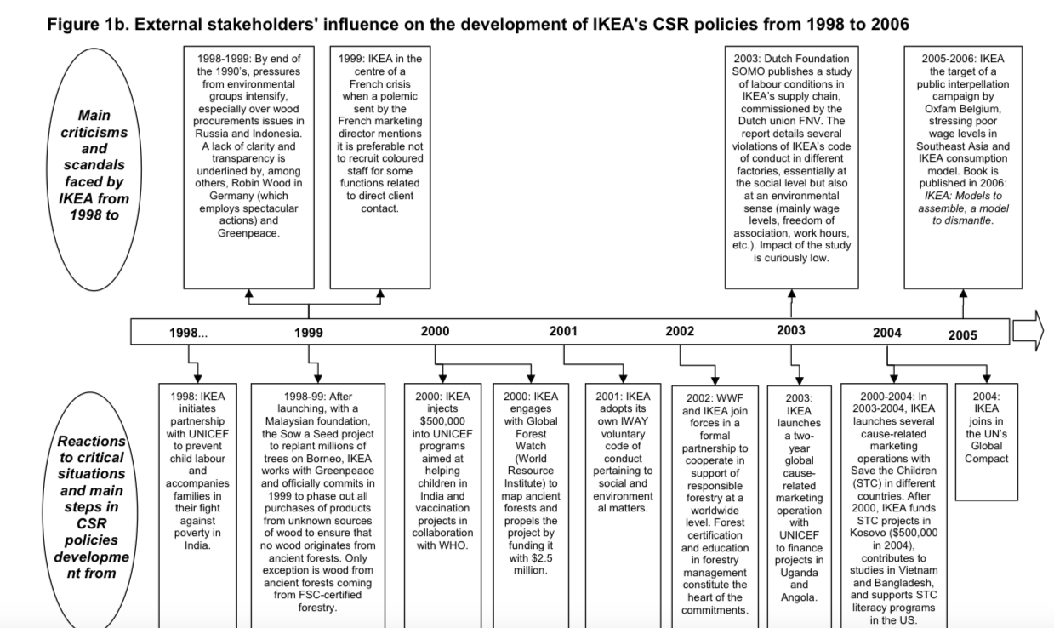
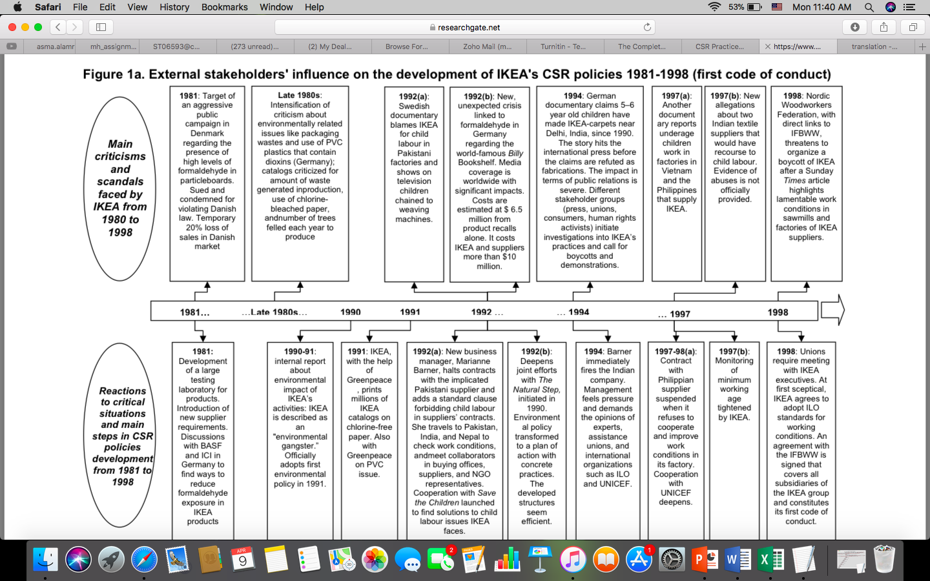
Three elements are apparent from Figures 1a and 1b: (1) the role of external stakeholders in developing socially and environmentally responsible business practices and codes of conduct (cf. Maignan and McAlister, 2003), (2) the role of NGOs in implementing and enforcing CSR agreements and codes of conduct (cf. Doh and Guay, 2004), and (3) the mix of reactive and proactive actions taken by IKEA. We consider each element next.

Problem 2

Independent organizations continuously assess and challenge the social and environmental measures implemented by IKEA; for example, Greenpeace, Robin Wood (a German environmental protection NGO), and SOMO (a Dutch research foundation) have repeatedly attacked IKEA for not respecting its environmental, social, and human rights responsibilities. As recently as 2006, studies identified serious problems in the way that IKEA implemented its codes of conduct, such as in terms of freedom of association and collective bargaining, salary levels, work conditions, and workers' rights (Bailly et al., 2006; de Haan and Oldenziel, 2003).

Problem 3

- Solutions that can be undertaken by the gov and corporate to finish these issues

Solution for problem 1

Reactive and Proactive Actions taken by IKEA As a result of these external pressures, IKEA has integrated its CSR objectives more systematically into its management philosophy and business operations. For example, IKEA decided to adapt in a response to social demands from public regulators (e.g., in Denmark and Germany), trade
unions (e.g., IFBWW, FNV), the media, and NGOs (e.g., Greenpeace, Robin Wood, Save the Children). Our findings demonstrate that IKEA reacts quickly when its image or reputation is challenged.

Solution for problem 3

The same year, IKEA's management established large-scale testing of its products and introduced new requirements for its suppliers. Because of its success in responding to such external criticism, IKEA has been nicknamed the "Teflon company" (Miller, 2001). However, IKEA also proactively seeks to anticipate stakeholders' demands. At the beginning of the 1990s, to transform its environmental policy into an efficient plan of action with concrete business practices, IKEA initiated a collaboration with Natural Step, an international, not-for-profit, research, educational, and advisory organization that uses scientifically developed system frameworks to help individuals, organizations, and communities take meaningful steps toward sustainability. IKEA also is a member of various business networks, including Business for Social Responsibility and Global Compact. For these and other partnerships, collaborations, and engagements.

IKEA is a unique brand because it capitalize on its strategic production model that help it to provide objects at less cost and bring innovation. The IKEA has a simple concept; save transportation cost and mass production for consumers. To create a competitive advantage using environment-friendly building practices, the whole life-cycle of the building should, therefore, be the context under which these practices are carried out (Ojo, Mbohwa & Akinlabi, 2015). The company requires their suppliers of products and services to follow the IKEA code of conduct, called The IKEA Way on Purchasing Products, Materials and Services (IWAY), which was first introduced in 2000. The IWAY states the supplier requirements relating to the environment, child labour, social and working conditions (Green Business Singapore, 2011). IKEA has developed a Sustainability Product Score Card to understand the impact of their designed product. The Score Card includes 11 criteria that have an impact on a product's sustainability throughout its life cycle, including:

  - More from less (using less material in the product)
  - Renewable material
  - Recycled material
  - Environmentally better material
  - Separable and recyclable material
  - Product quality
  - Transport efficiency (number of products per container)
  - Energy efficient production
  - Renewable energy in production
  - Raw material utilization at suppliers
  - Product use (less use of energy and water, and less waste in customers' homes)

KEA has developed production centres and use less energy for their products. It mostly uses renewable energy and less raw material. IKEA is working with suppliers in energy projects to help them reduce energy consumption and carbon dioxide emissions, while saving costs. IKEA is also helping customers and co-workers use more sustainable modes of transport to travel to and from IKEA stores. Together, these instruments constitute a part of the binding business contract between IKEA and its suppliers.

IKEA sustainability contribution.. مساهمة IKEA المستدامة

IKEA participates in various activities, such as the Forest Stewardship Council and the Roundtable for Sustainable Palm Oil certification (Boström, Gilek, Jönsson & Karlsson, 2013). IKEA is totally aware of its environment responsibilities and take all precautionary measures to be less dependent on environmental resources. It uses renewable energy and low carbon footprint for its production.
IKEA has already established itself as a 'Green Corporate' but it is also necessary to integrate social, environmental and economic dimensions in other business related to the company. The following steps could be adopted to in identifying key performance indicators:
- Setup independent management review body to assess practises and impact on macro and micro level
- It should develop a knowledge sharing system for consumers to understand the company's practices and implement learnt lessons on their part.
- It should encourage direct and indirect stakeholders to come forward and take initiative in establishing sustainable practices and ideas.

Analyzing changes in the organization's external environment, identifying key stakeholders, and re garding CSR as a promising path
Their increasing dependence on financial investors' expectations about their performance and public opinion means t hat organizations must demonstrate their thorough understanding of the changes in their external environments. In particular, organizations must be awar e of who their stakeholders are and what expectations they hold. Our case study reveals that IKEA has faced many potential crises, including those related to work safety, wood from certified sustainable forests, and CO
2
emission levels, which prompted it to engage in discussions and negotiations with trade unions, its supplier network, NGOs, and the media. In deali ng with these different crises, IKEA has found that its CSR can deliver promising solutions and ultimately lead to better corporate performance.

Communicating with external stakeholders using appropriate tools IKEA has not felt the need to advertise its CSR commitments; rather than relying on advertising rhetoric, it trusts in factual information. In addition, IKEA uses appealing elements, such as family, cultural, and ethical values, to portray its CSR commitments. Furthermore, IKEA carefully and efficiently maintains its image, then selects some specific CSR commitments, such as children's rights and reduced environmental impact, to communicate. With regard to organizational and institutional stakeholders, IKEA uses specifically adapted communication means, such as its annual CSR report. Our findings
highlight the complexity associated with reaching decisions about the nature and level of communication. For example, the need to communicate varies depending on the type of stakeholder and the importance that the stakeholder places on CSR, as well as the stakeholder's potential influence. In the case of IKEA, NGOs and trade unions have been more influential than consumers, so communication with these external stakeholders adds more value.

Conclusion

CONCLUSIONS AND DISCUSSIONS
Drawing from our developm ent of the case, we outline some key strategic implications for IKEA and organizations interested in CSR in general. The effective influence of stakeholders in the CSR development process and the variability of their percept ions about CSR activities and communication should prompt researchers to analyze CSR dev elopment issues and conduct impact analyses in a more comprehensive manner than currently exists. The crucial role of stakeholders' differential perceptions about the transparency and credibility of information about an organization's CS R commitments should remain central to any research effor t; thus, our identific ation of different stakeholders' unique attitudes towa rd IKEA represents an important contribution.
As does most research, this study has several limitations that affect our interpretation of the findings and suggest di rections for further research. First, our study is based on a single-case approach. Second, though we interviewed stakeholders from various European countries, the Belgian context predominates in the interviews of union representatives and local authorities and therefore may influence or bias the analysis. In addition, though we gathered information from a representativ e sample of external stakeholders, we could not address every category of stakeholder. Third, we integrate end customer input only through surveys. Direct end customer input, particularly with regard to ethical attri butions, could increase the validity of our customer value analysis model. Fourth, our research is limited to an a posteriori analysis of CSR policies in a particular industry, which does not allow us to observe the formation or shifts in the key stakeholders' perceptions and attitudes directly. Real time and long itudinal data, rather than historical information and interviewee recall, wo uld therefore extend our study effectively.

Other potential future research avenues include a comparative analysis of the role of various stakeholders in the organization's development of its CSR policies. In this sense, it would be worthwhile to evaluate comprehensively and systematically the influence of different stakeholder groups on organizational changes demanded by the integration of CSR principles into corporate strategy. Related CSR communicational choices thus might be revised and tailored to the expectations of each particular category of stakeholders. Finally, the impact of organizational and strategic changes on
the perceptions and attitudes of various stakeholders should be highlighted during different steps of the integration process.

Reference List

Aguinis, H., & Glavas, A. (2012). What we know and don't know about corporate social responsibility a review and research agenda. Journal of management, 38(4), 932-968.
Boström, M., Gilek, M., Jönsson, A. M., & Karlsson, M. (2013). IKEA and the Responsible Governance of Supply Chains: IKEA's work on chemicals in textiles.
Dahlsrud, A. (2008). How corporate social responsibility is defined: an analysis of 37 definitions. Corporate social responsibility and environmental management, 15(1), 1-13.
Green Business Singapore. (2011). How IKEA Embraces Sustainability Globally and in Singapore |Greenbusiness.sg. Retrieved 6 May 2016, from http://www.greenbusiness.sg/2011/05/24/how-ikea-embraces-sustainability-globally-and-in-singapore/
Maon, F., Swaen, V., & Lindgreen, A. (2010). Impact of CSR commitments and CSR communication on diverse stakeholders: The case of IKEA. Global challenges in responsible business: corporate responsibility and strategy, 161-190.
Matten, D., & Moon, J. (2008). "Implicit" and "explicit" CSR: a conceptual framework for a comparative understanding of corporate social responsibility. Academy of management Review, 33(2), 404-424.
Ojo, E. M., Mbohwa, C., & Akinlabi, E. T., (2015). Sustainability-Competitive advantage?. International Conference on Operations Excellence and Service Engineering, Orlando, Florida, USA.
https://www.ukessays.com/essays/business/csr-practices-ikea-8228.php
https://www.researchgate.net/profile/Francois_Maon/publication/242642271_Corporate_Social_Responsibility_at_IKEA_commitment_and_communication/links/56af186308ae28588c62c281/Corporate-Social-Responsibility-at-IKEA-commitment-and-communication.pdf

IKEA Group (2003) IKEA: Social and environmental responsibility report.
http://www.ikea- group.ikea.com/corporate/PDF/IKEA%20Report2003.pdf
, accessed June 22, 2006.
IKEA Group (2006) Social and Envir onmental Responsibility brochure.
http://www.ikea-group.ikea.com/ corporate/PDF/Brochure.pdf
, accessed June 22, 2006.
IKEA UK website (2006)
http://www.ikea.com/ms/en_GB/about_i kea/press_room/student_info.ht ml
, accessed June 22, 2006.
Jick, T.D. (1979) Mixing qualitative and quantitative me thods: triangulation in action, Administrative Science Quarterly , 24(4), 602-611.
Lamberg, J.O., Savage, G.T . and Pajunen, K. (2003)
Strategic stakeholder perspective to ESOP negotiations: the case of United Airlines,
Management Decision , 41(4), 383-393.

